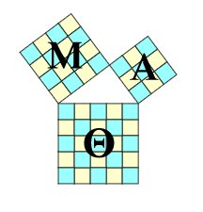
Mu Alpha Theta
Friday, November 16th, 2012
12:18 pm
Room E6 Capistrano Valley High School
Minutes

Call to Order
A regular meeting of Mu Alpha Theta was called to order at 12:20 pm by President Francis Yang
Roll Call
Present: Francis Yang
Justin Su
Meagan Shinbashi
Matt Warnagieris
Steven Radoijicic
Michael Leek
Renee Cai
Jonathon Wickes
Cooper Upson
Alex Ng
Daniel Achee
Daniel Wong
Hao Zhou
Colin Wang
Candace Pham
Staff: Mrs. Kubba, Club Advisor

Old Business
December Tournament:
Signups for Volunteer Positions covered.
Promotion-
Phone Calls
Flyer printing designated to Club Member Alex Ng.
Time of Tournament for volunteers, determined to be from 7:30-1:30
Difficulty level of the questions, AMC 8 and below for 6th and 7th graders, ideal number of questions around 70.
Problem Making Session -
Senior Center/Norman P. Murray Center, rent a room 12:00 - 3:00 Monday November 19th
Everyone contributes food.

New Business
Tutoring:
Soccer player tutoring on Thursdays during Lunch in Mrs. Kubba's room E6.

Committee Member Comments
Unanimous decision for tournament times and problem making date, promotion stressed, sign-ups complete for present members.

Adjournment
At the hour of 12:50, there being no further business to come before Mu Alpha Theta, the meeting was adjourned to Monday, November 19th at 12:00.

